Cloud Architect, Cloud Network Engineer

Compute, Networking

**Lab Steps**

Task 1: Sign in to AWS Management Console

1. Click on the  button, and you will get redirected to AWS Console in a new browser tab.
2. On the AWS sign-in page,

* Leave the Account ID as default. Never edit/remove the 12 digit Account ID present in the AWS Console. otherwise, you cannot proceed with the lab.
* Now copy your **User Name** and **Password** in the Lab Console to the **IAM Username and Password** in AWS Console and click on the **Sign in** button.

1. Once Signed In to the AWS Management Console, Make the default AWS Region as **US East (N. Virginia) us-east-1.**

**Note :**If you face any issues, please go through [**FAQs and Troubleshooting for Labs**](https://business.whizlabs.com/labs/support-document/faqs-and-troubleshooting).

Task 2: Creating Launch Template

1. Make sure you are in the **US East (N. Virginia) us-east-1** Region before proceeding with the Lab.
2. Navigate to **EC2** by clicking on the  menu in the top, then click on **EC2** in the **Compute** section.
3. In the left navigation pane (scroll down) within **Launch Templates**, click on the **Instances.**
4. Click on 
5. Launch template name: ***whizlabsLT***
6. Launch version description: ***Launch template version 1***
7. Launch template contents:
   * Amazon machine image (AMI): **Amazon Linux 2 AMI (HVM), SSD Volume Type**  
     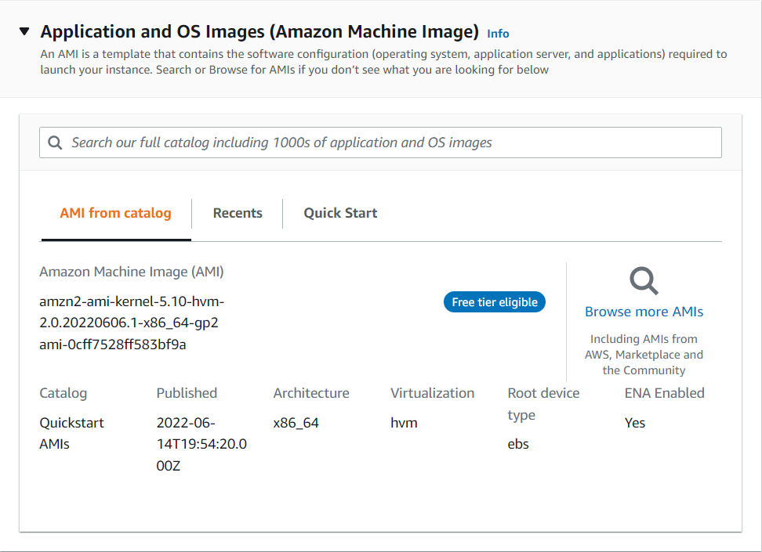
   * Instance type: Select **t2.micro**  
     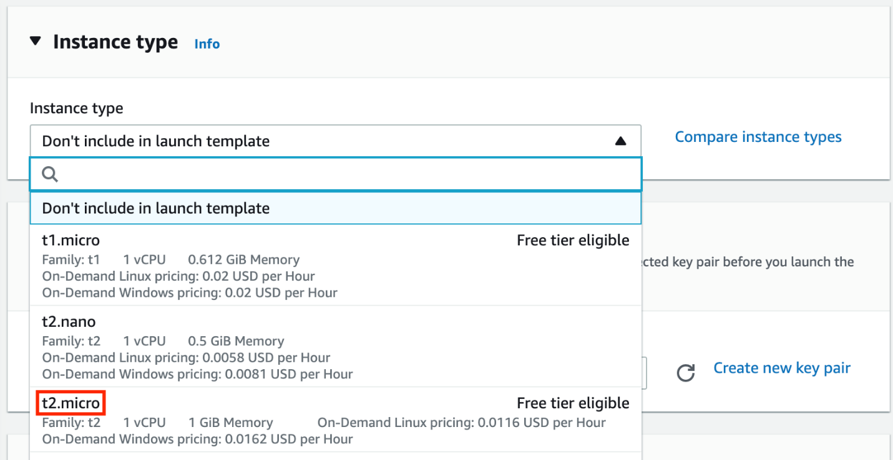
   * Key pair (login):
     + Key pair name: **Don't include in launch template**  
       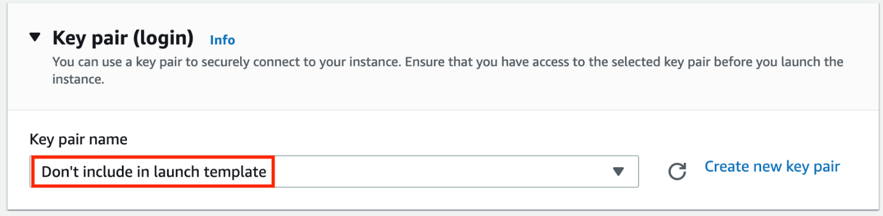
8. Network settings: Select **Virtual Private Cloud (VPC)**
   * Security groups: Select the **Default security group of Default VPC**
9. Keep all the settings as default.
10. Now, click on 
11. Launch template is now created.
12. Click on the 
13. Launch template is now listed.  
    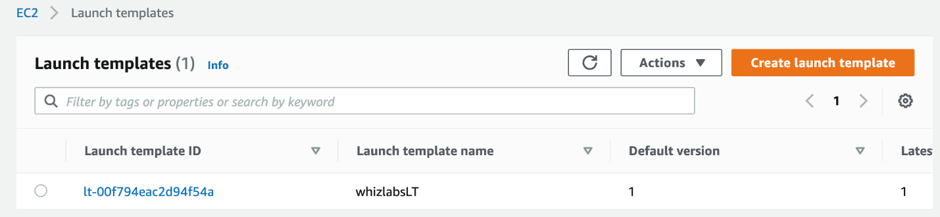

Task 3: Create an Auto Scaling Group

1. An Auto Scaling group is a scalable collection of EC2 instances. When you create an Auto Scaling group, you include information such as the subnets for the instances and the number of instances the group must maintain at all times.
2. Go to the left menu under **EC2** and choose **Auto Scaling Groups**  under **Auto Scaling**
3. Click on the 
4. **Step 1: Choose launch template or configuration**
   * Auto Scaling group name: Enter ***whiz-ASG***
   * Launch template: **whizlabsLT**
   * Click on the  button.
5. **Step 2: Configure settings**
   * VPC: Select the **Default VPC** from the list.
   * Subnet: Select one or more subnets for your Auto Scaling instances.
   * Click on the 

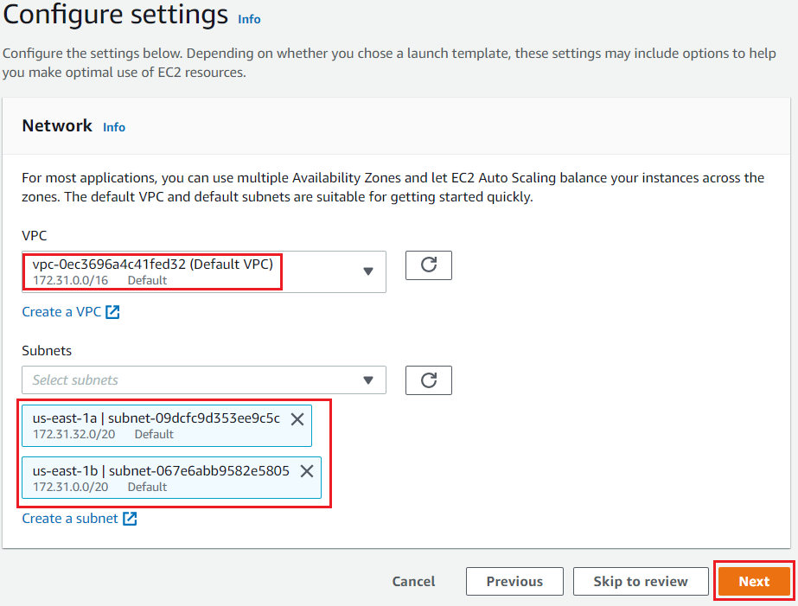

1. **Step 3: Configure advanced options**
   * No changes are needed on this page, click on the 
2. **Step 4: Configure group size and scaling policies**
   * Under Group size - optional
     + Desired capacity: Enter ***2***
     + Minimum capacity: Enter ***2***
     + Maximum capacity: Enter ***2***

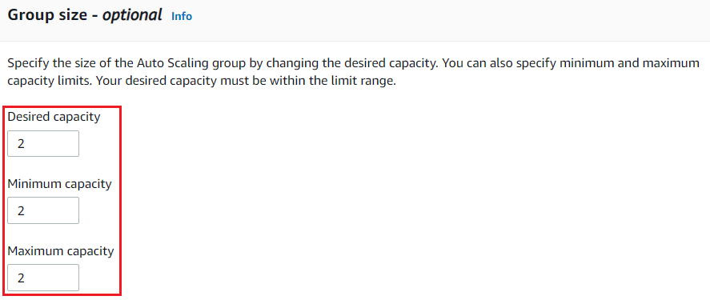

* Under Scaling policies - optional
  + Select **None**

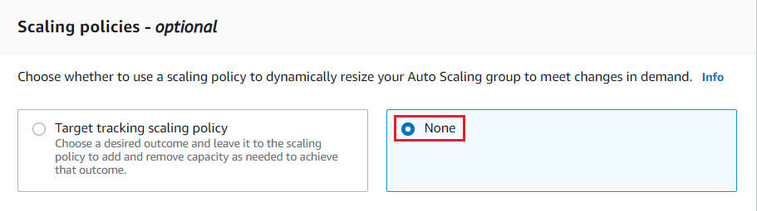

* Under Instance scale-in protection
  + No changes are needed, click on the 

1. **Step 5: Add notifications**
   * No changes are needed on this page, click on the 
2. **Step 6: Add tags**
   * Enter tags in key-value pairs to identify your auto-scaling group.
   * Click on the  button.
   * Key: **Name**
   * Value: **ASG-EC2**  
     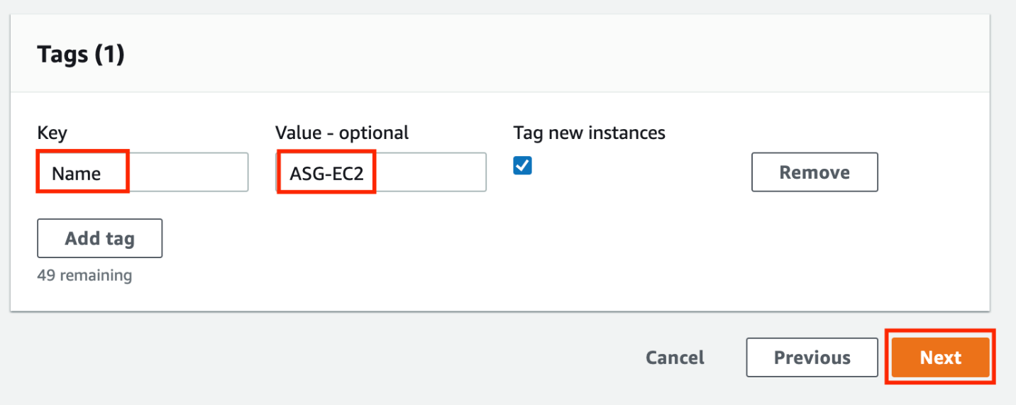
   * Click on the 
3. Now scroll down and click on the 
4. Whiz-ASG Auto scaling is created successfully.  
   
5. You will be redirected to the autoscaling group page, you will be able to see that two instances are launched by the autoscaling group.
6. Now go to the EC2 instances list. You will see that there are **two new running instances** (which were created by your autoscaling group) You can confirm this from their tag name, which you gave at the time of creating the autoscaling group.
7. You have successfully created an autoscaling group with a policy of a minimum of 2 and a maximum of 2 instances.

Task 4: Test Auto Scaling Group

1. For testing the auto-scaling policy, go to the EC2 instance list and select one of your instances.
2. Next, select an instance and click on **Instance state**and then **Stop instance.**
3. Click the **Stop** button on the pop-up window to stop your instance.
4. Once your instance is stopped (after 1-2 minutes) you can see that your stopped instance will be terminating automatically, and a new instance will be launched to fulfill the policy condition. A sample screenshot is provided below:  
   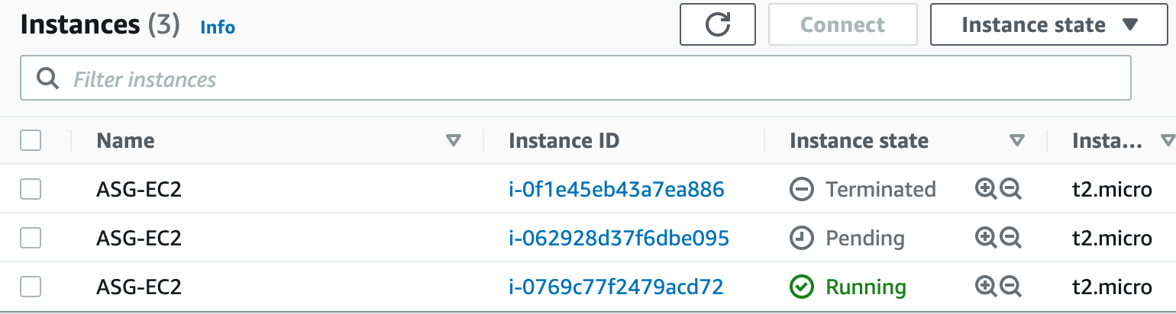

* **Note:**Launching a new instance may take a few minutes, you can refresh the page to view the new instance.

Task 5: Validation Test

1. Once the lab steps are completed, please click on the  button on the left side panel.
2. This will validate the resources in the AWS account and displays whether you have completed this lab successfully or not.
3. Sample output :

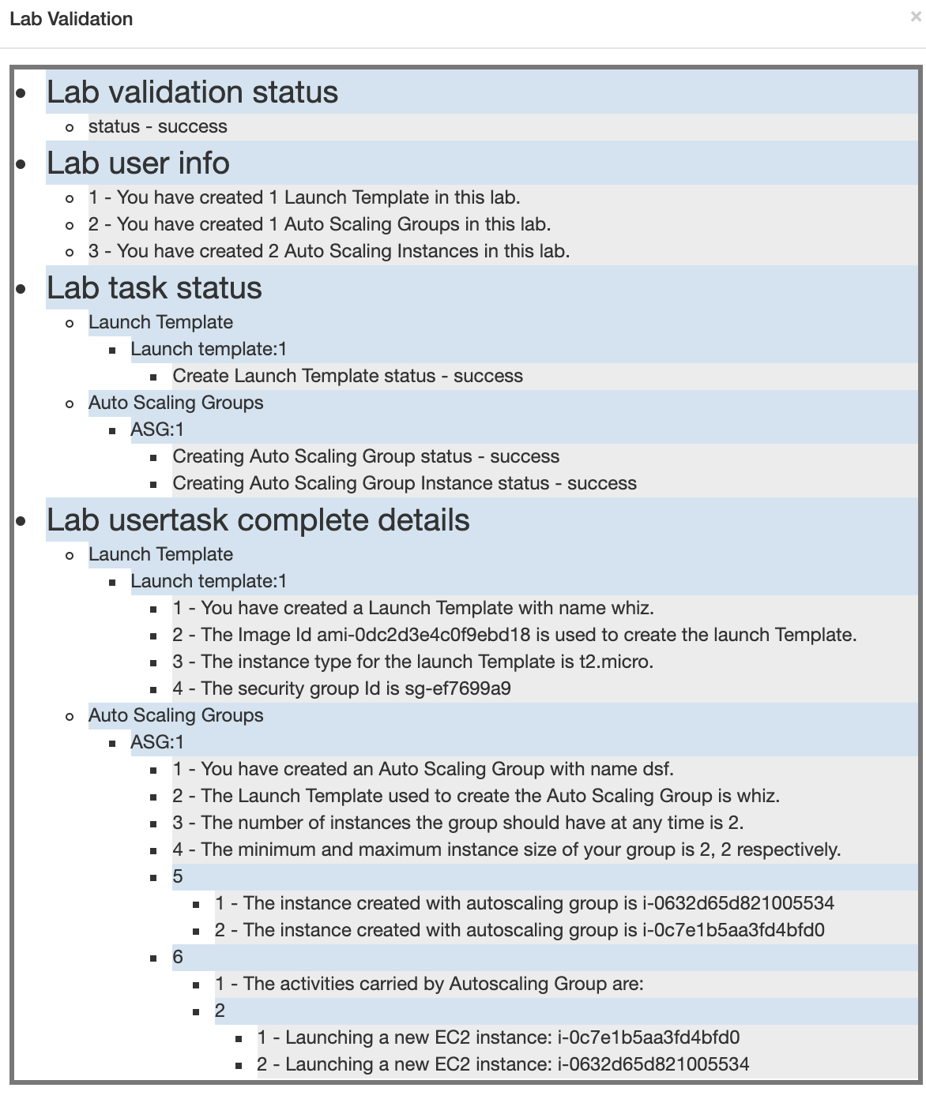

**Completion and Conclusion**

1. You have successfully used the AWS management console to create a Launch Template.
2. You have configured your own details while creating an Auto Scaling Group.
3. You stopped an EC2 instance to verify a replacement instance would be created, as per the requirement.

End Lab